Idea From Nobel Prize in Economic Sciences 2023—YUE ZHAO

***Key drivers of gender differences in the labor market–cause of change and main sources of remaining gender gap.***

Datasource:

1.[Gender Data Portal From The World Bank](https://genderdata.worldbank.org/)

**Introduction:**

Globally, around 50% of all women are in paid employment, while the equivalent figure for men is 80%. When women work, they usually earn less, even in the society where women already have high levels of employment and are perhaps more highly educated than men.

Understanding how and why levels of employment and earnings differ between women and men is important for socioeconomic reasons. The issue relates to the most efficient use of society’s resources. It is economically inefficient for jobs not to go to the most qualified person and, if pay differs for performing the same work, women may be disincentivised to work and have a career.

**Questions of Interest( Overall Look+Parenthood+Education)**

* Does economic growth have a positive association with women’s participation rate in the labor market?( Collect historical records for the study of long-run female laobr market outcomes beyond US)
  + Analysis between developed and developing countries?

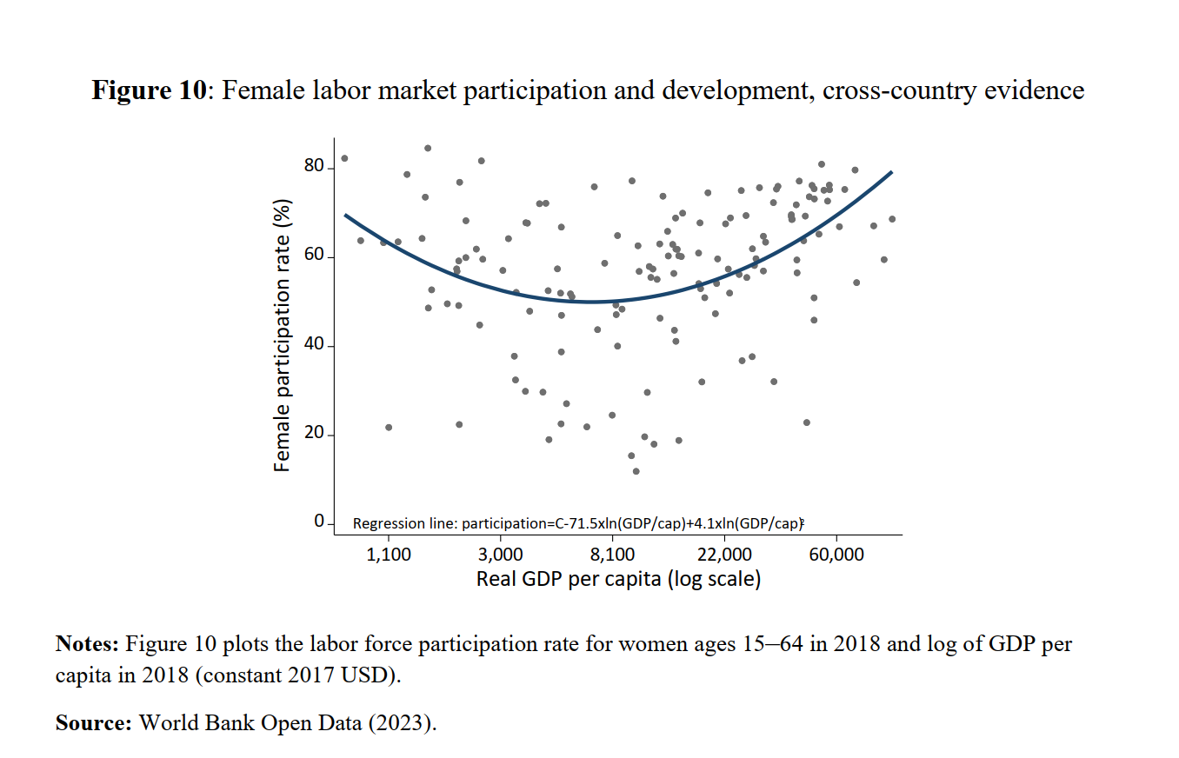

* + Participation gap between woman and man across countries: From the world bank data portal, data shows some area exceeds 50%
  + According to OECD, women earn on average 13% less than men.
* What’s the relationship between education level and rate gap?
  + Control differences
  + 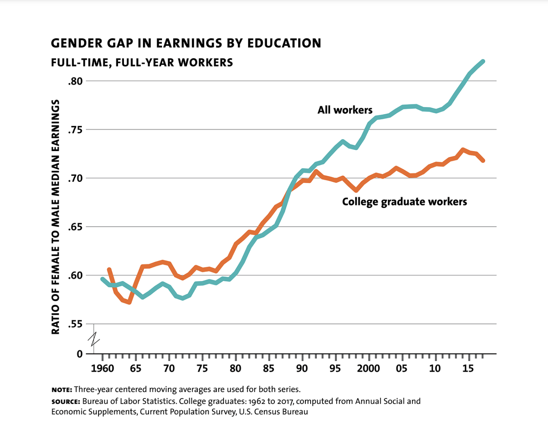
* How does the “marriage bars” influence the female labor market?(expectation difference in expected working hours ... .average employment level…pay discrimination….the parenthood effect….(after first child…) )
  + Study the parenthood of female labor market outcomes.
  + Study the role of workplace structure and flexibility in explaining labor market gender gaps.
  + 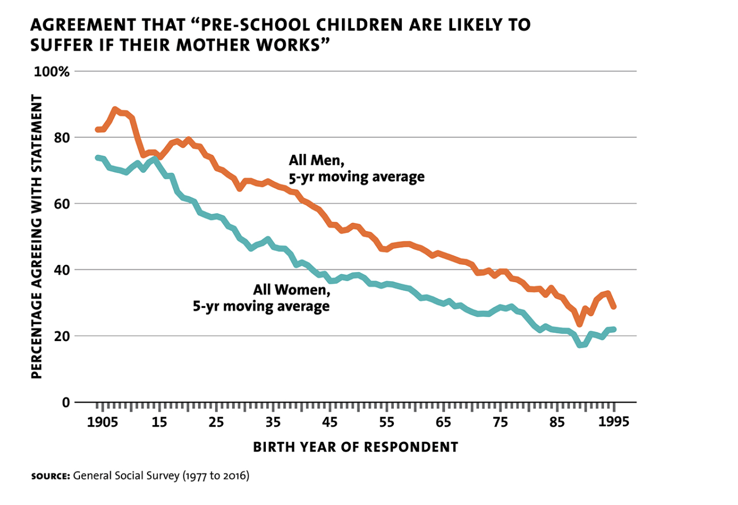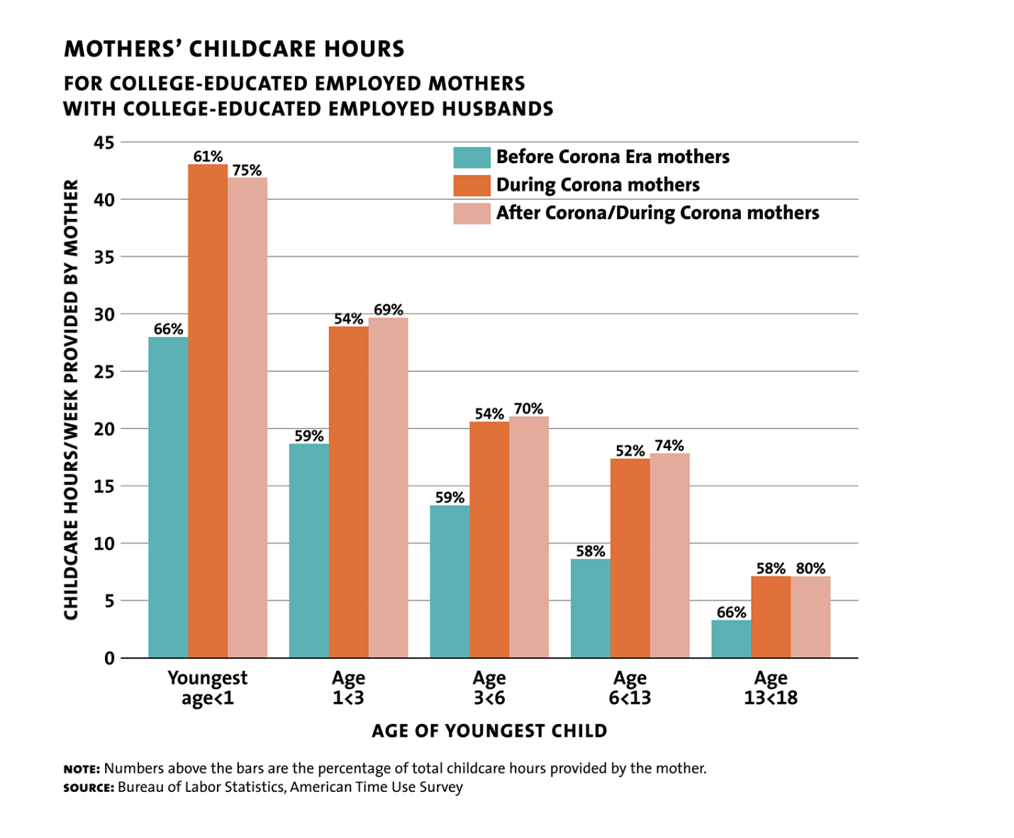
  + 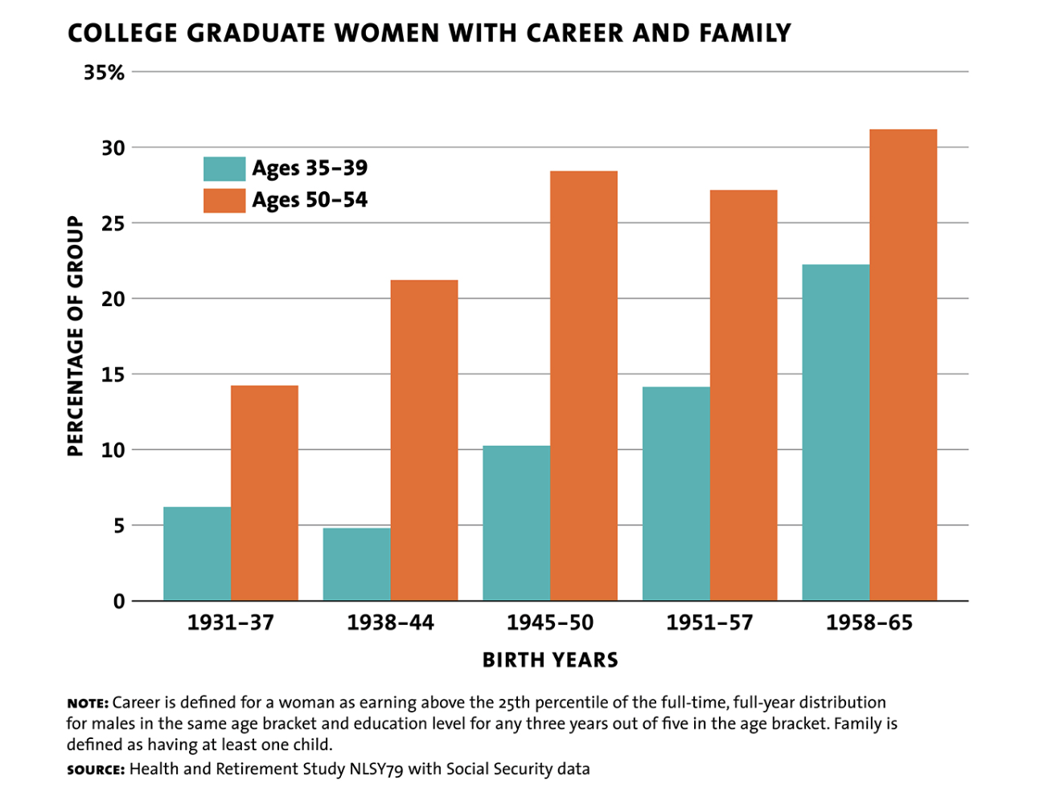
* How does the pill influence the labor rate? (delay marriage and childbirth…discover the relationship between pills and employment rate)
* Consider alternative or complementary explanations, such as gender stereotypes.

Work norms: difference between different conuntry.

Fertility leave:

* How policy interventions impact these gender gaps?(
  + Pick policy examples and study the effect.

Reference:

1.Press release:<https://www.nobelprize.org/prizes/economic-sciences/2023/press-release/>

2.Popular science background: [History helps us understand gender differences in the labor market](https://www.nobelprize.org/uploads/2023/10/popular-economicsciencesprize2023.pdf)

3.Scientific background by nobel:<https://www.nobelprize.org/uploads/2023/10/advanced-economicsciencesprize2023.pdf>

4.[Journey Across a century of women](https://www.milkenreview.org/articles/journey-across-a-century-of-women?IssueID=40)

Datasource:

1.[Gender Data Portal From The World Bank](https://genderdata.worldbank.org/)

# [Gender Data Availability](https://genderdata.worldbank.org/data-availability/?tab=availability)

“Women are severely underrepresented in the global labor market: around 50% of women work or actively seek work for income, compared to 80% for men. The gender differences in participation are fundamentally driven by variation in women’s participation rates – men’s participation rates are broadly constant across time and countries. The participation gaps between men and women are particularly large in South Asia, the Middle East, and North Africa, where they sometimes exceed 50 percentage points.”

[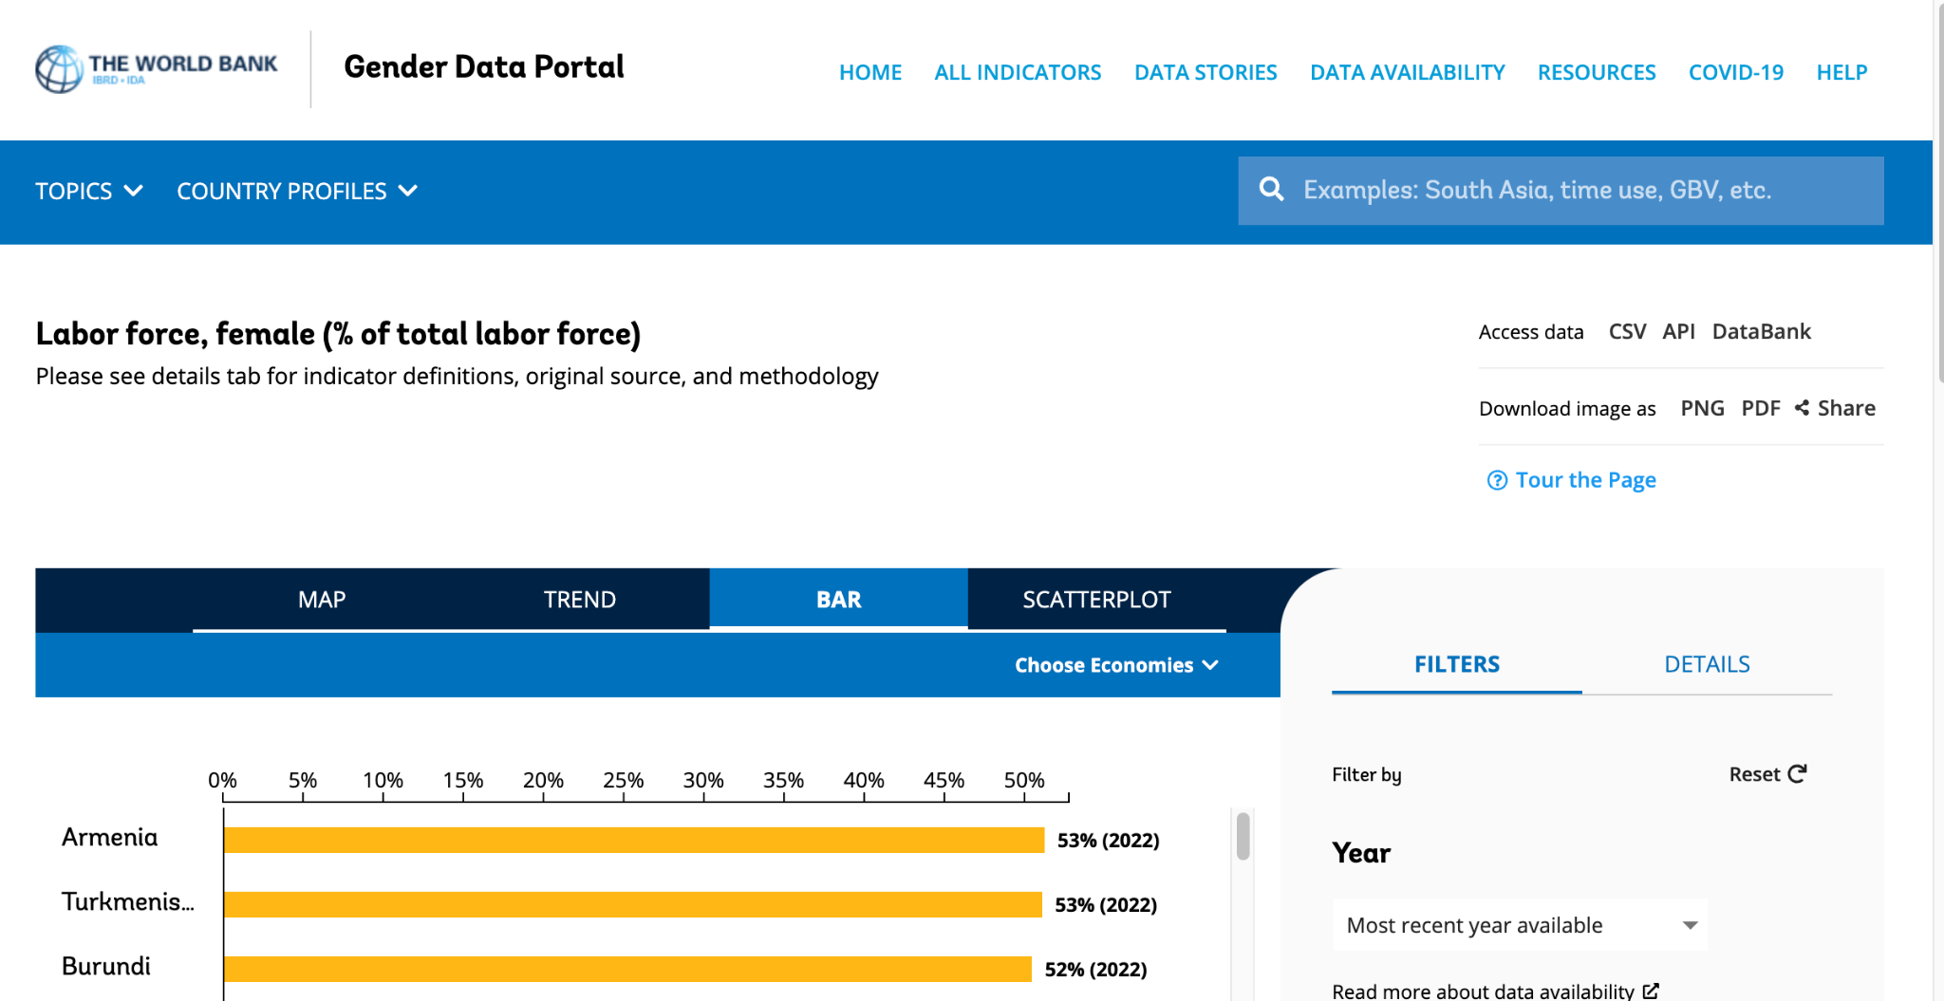](https://genderdata.worldbank.org/indicators/sl-tlf-totl-fe-zs?view=correlation)

[2. Wage Levels From the OECD](https://data.oecd.org/earnwage/gender-wage-gap.htm#indicator-chart)

“Equal participation does not, however, imply gender equality, as gender gaps exist in many other dimensions of the labor market. When women work, they earn less: across the OECD, for example, women earn on average 13% less than men.2 Moreover, women tend to work in jobs with less room for promotion and are severely underrepresented on corporate boards or as CEOs. Gender gaps in earnings and the “glass ceiling” in promotions are worldwide phenomena”

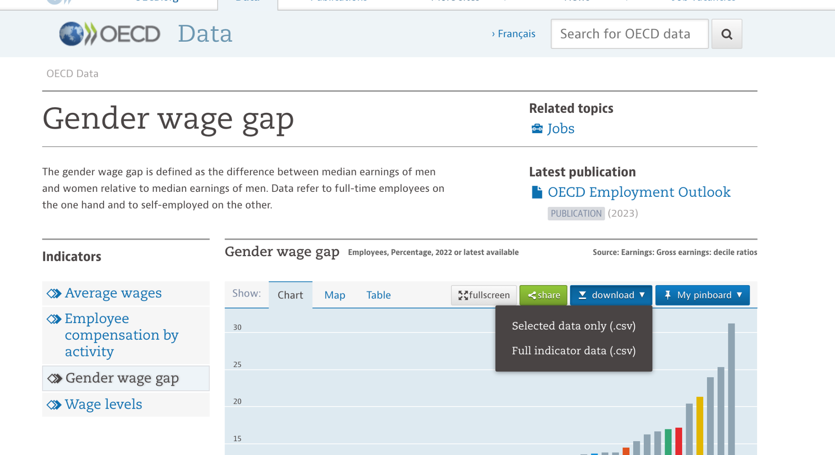

3.Kaggle Dataset-[Gender Wage Gap in the US](https://www.kaggle.com/datasets/asaniczka/gender-wage-gap-in-the-usa-1973-2022)

[4. US BUREAU OF LABOR STATISTICS](https://www.bls.gov/)

[NLSY79 Data](https://www.bls.gov/nls/nlsy79.htm)(The NLSY79 is a nationally representative sample of 12,686 young men and women born during the years 1957 through 1964 and living in the United States when the survey began.)

5. [The General Social Survey](https://gss.norc.org/get-the-data)